

BALAGAN SARASWATHI
ARTS AND SCIENCE COLLEGE FOR WOMEN
Affiliated to Manonmaniam Sundaranar University , Tirunelveli

MUKKUDAL, TIRUNELVELI-627601

NAAN MUDHALVAN PROJECT
HTML QUICK STYLER
Submitted By:

A.Hamsa Jesi | 23081441802112005
M.Jasmine | 23081441802112006
R.Kiruthika | 23081441802112007
S.Manju | 23081441802112008

DECLARATION
We are done hereby that this project is in Entitled of “HTML QIUCK STYLER” is the project work done by us under the guidance of Mrs.S.Inbaroja M.C.A., D.El.ED., B.Ed., Assistant Professor of Computer Science submitted in partial fulfillment of the requirements for the degree of Bachelor Computer Science at BALAGAN SARASWATHI ARTS AND SCIENCE COLLEGE in Mukkudal.

Name of the Student Signature of the Student

A.Hamsa Jesi | 23081441802112005
M.Jasmine | 23081441802112006
R.Kiruthika | 23081441802112007
S.Manju | 23081441802112008

Place:

Date:

ACKNOWLEDGEMENT
I would like to express my sincere gratitude to all those who have contributed to the successful completion of this project on “NAAN MUDHALVAN-HTML QUICK STYLER”
We take this opportunity to places my sincere thanks to the my parents for their constant blessings and support throughout our life.
We express our’s sincere thanks to our beloved Secretary and Correspondent Balagan Arumugasamy, Balagan Saraswathi Arts and Science College for Women.
Our’s sincere thanks to Principal Dr.R.Krishnaveni M.Com., M.B.A., M.Phil.,Ph.D. Balagan Saraswathi Arts and Science College for Women, Mukkudal for giving an all encouragement and enthusiasm a successful completion of our project work within the stipulated time.
We highly oblique to Mrs.A.Anitha M.Sc., B.Ed., M.Phil., The Head of the Department Assistant Professor of Computer Science for her constant encouragement that help us overcome barriers in the successful completion of the project.
We express our sincere gratitude to Mrs.S.Inbaroja.,M.C.A., D.El.Ed., B.Ed., ,Our Guide and Assistant Professor of Computer Science, for her’s unwavering support and encouragement which helped us overcome challenges and successfully complete this project.
We sincerely thank our Department facilities for their valuable suggestions and
advise. I express my sincere thank to all those generously helped us to make this project a
success.
HTML Quick-Styler
AI-Powered HTML Page Generator with IBM Granite 3.3 2B

Project Description
HTML Quick-Styler is an intelligent web page generation platform that leverages IBM&#39;s Granite
3.3 2B Instruct model to provide comprehensive HTML/CSS page creation with professional
styling and responsive design. The platform addresses the challenge of rapid web development
by delivering AI-powered HTML generation, automatic section detection, modern CSS styling,
color palette management, and production-ready code output.
Using Granite 3.3 2B&#39;s advanced language capabilities, the system analyzes user descriptions
(page title, section requirements, color preferences), generates semantic HTML structure,
applies modern CSS styling with animations, creates responsive layouts, and provides multiple
color palette options. The system ensures professional output through Gradio&#39;s user-friendly
interface while maintaining high-quality design standards through sophisticated template
generation and AI-powered content suggestions.
HTML Quick-Styler transforms web development into an intelligent, user-friendly experience
through its modern Gradio interface, comprehensive feature set, and AI-powered analysis that
provides personalized HTML pages considering design trends, accessibility standards, and
responsive design principles.Scenarios

Scenarios
Scenario 1: Portfolio Website Generation
A freelance designer wants to create a professional portfolio website quickly and efficiently. The
system first detects the project requirements and analyzes the designer’s style and design
preferences. Based on this understanding, it generates a complete website structure that
includes a visually appealing hero section with a welcoming message and a strong call-to-action
to engage visitors immediately. It also builds a responsive portfolio gallery arranged in a clean
grid layout to showcase projects effectively across devices. An about section is created to present
the designer’s professional bio in a compelling manner, helping visitors understand their
background and expertise. To strengthen credibility, the system includes a testimonials section
featuring client feedback. A contact form with proper input validation ensures smooth
communication while preventing errors, and finally, a professional footer is added with social
media links and essential information to complete the polished look of the website.
Scenario 2: SaaS Landing Page
A startup needs a powerful landing page for launching their new product. The system responds
by creating a compelling hero banner that clearly communicates the product’s value proposition
and key messaging. It then generates a features showcase section, presenting product
capabilities with visually appealing icons and concise descriptions to make the benefits easy to
understand. A pricing comparison table is designed with clear plan options to help potential
customers make informed decisions. To build trust and credibility, the system incorporates a
testimonials section that highlights positive user experiences and social proof. Prominent and
strategically placed call-to-action buttons are added throughout the page to guide visitors
toward signing up or purchasing, ensuring strong conversion optimization.
Scenario 3: Corporate Website
A company requires a professional corporate website with multiple structured sections. The
system delivers a clean and polished layout starting with a sticky navigation header that includes
company branding and allows smooth navigation across sections. It creates a company overview
section that clearly communicates the organization’s mission, vision, and core values. A services
grid is generated to present detailed descriptions of the company’s offerings in an organized and
visually structured manner. The website also includes a team members section with photos and
short profiles to add a human touch and build trust with visitors. Additionally, a contact section
is implemented with company information and an inquiry form for seamless communication.
The site is completed with a professional footer containing privacy policies and important links,
ensuring a corporate-standard presentation.
Scenario 4: Custom Color Palette Exploration
A designer wants to experiment with different color schemes to find the perfect visual identity
for their project. The system generates eight carefully curated pre-designed color palettes,
including modern, vibrant, ocean, forest, sunset, luxury, creative, and minimal themes. Each
palette comes with clearly defined hex color codes for every component, making implementation
straightforward. The system provides a real-time preview feature, allowing the designer to
instantly visualize how each color scheme affects the overall design. It ensures consistent color
application across all page elements to maintain visual harmony. Additionally, dark
theme–optimized backgrounds are included to support modern design trends and improve user
experience in low-light viewing environments.

Architecture Overview
HTML Quick-Styler is built as a modular platform combining Python backend with IBM Granite
3.3 2B Instruct model for intelligent HTML generation. The architecture prioritizes user
experience, design quality, and code production through Gradio&#39;s interactive interface and
sophisticated template generation.
Core Technologies
• Python 3.x: Core programming language for application logic
• IBM Granite 3.3 2B Instruct: AI model for intelligent content generation
• Gradio: Interactive web interface framework for user interaction
• HTML5/CSS3: Modern web standards for page generation
• JavaScript: Client-side interactivity and animations
• Google Colab: Cloud-based development environment
• Responsive Design: Mobile-first approach with media queries

Pre-requisites
Software Requirements
• Python 3.8+: Download from python.org
• Google Account: Required for Google Colab access
• Gradio: Install via pip (pip install gradio)
• Web Browser: Chrome, Firefox, Safari, or Edge
• Internet Connection: Required for Colab and model access
Knowledge Prerequisites
• Python Basics: Functions, classes, dictionaries, string manipulation
• HTML/CSS: Understanding of HTML structure and CSS styling
• Gradio Framework: Basic understanding of interface components
• Web Design: Color theory, responsive design principles
• Google Colab: Familiarity with notebook interface

Hardware Requirements
• Processor: Intel i3 or equivalent (Colab runs on cloud)
• RAM: Minimum 4GB local (Colab provides GPU/TPU)
• Storage: 1GB free space for generated files
• Display: Minimum 1280x720 resolution for interface

Project Workflow
Phase 1: Environment Setup &amp; Model Configuration
Establish Google Colab environment and configure Granite model
Activity 1.1: Set up Google Colab Environment
• Create new Google Colab notebook
• Enable GPU runtime for better performance
• Install required Python packages
• Verify environment configuration
Activity 1.2: Configure IBM Granite Model
• Access Hugging Face model repository
• Load Granite 3.3 2B Instruct model
• Test model inference capabilities
• Configure generation parameters
Activity 1.3: Install and Configure Gradio
• Install Gradio via pip
• Test basic Gradio interface
• Configure sharing options
• Verify interface rendering

Phase 2: Core Application Development
Build HTML generation engine and template system
Activity 2.1: Build Color Palette Generator
• Create ColorPaletteGenerator class
• Define 8 color palette schemes
• Implement palette selection logic
• Add color validation methods
Activity 2.2: Implement HTML Page Builder
• Create HTMLPageBuilder class
• Build section detection algorithm
• Implement template generation methods
• Create SEO meta tags generator
Activity 2.3: Develop CSS Generation Engine
• Build comprehensive CSS generator
• Implement responsive design rules
• Add animation and transition effects
• Create mobile-first media queries
Activity 2.4: Build Section Templates
• Create hero section template
• Build features grid template
• Implement portfolio gallery template
• Add contact form template
• Create pricing and testimonial templates

Phase 3: Gradio Interface Development
Create interactive user interface with multiple tabs
Activity 3.1: Interactive HTML Generation &amp; Preview Interface
Activity 3 focuses on designing and implementing a complete HTML generation and
visualization interface that enables users to create, customize, preview, and understand web
page layouts through an intuitive, multi-section workflow.

Phase 4: Google Colab Deployment:
Integrate all components and perform comprehensive testing
Activity 4.1: End-to-End Integration
• Connect all interface components
• Test data flow between tabs
• Validate generation pipeline
• Test error handling

Phase 5: Deployment &amp; Documentation
Deploy application and create comprehensive documentation
Activity 5.1: Functionality testing
• Configure Gradio sharing settings
• Enable public access link
• Test external access
• Document deployment steps

Project Structure:
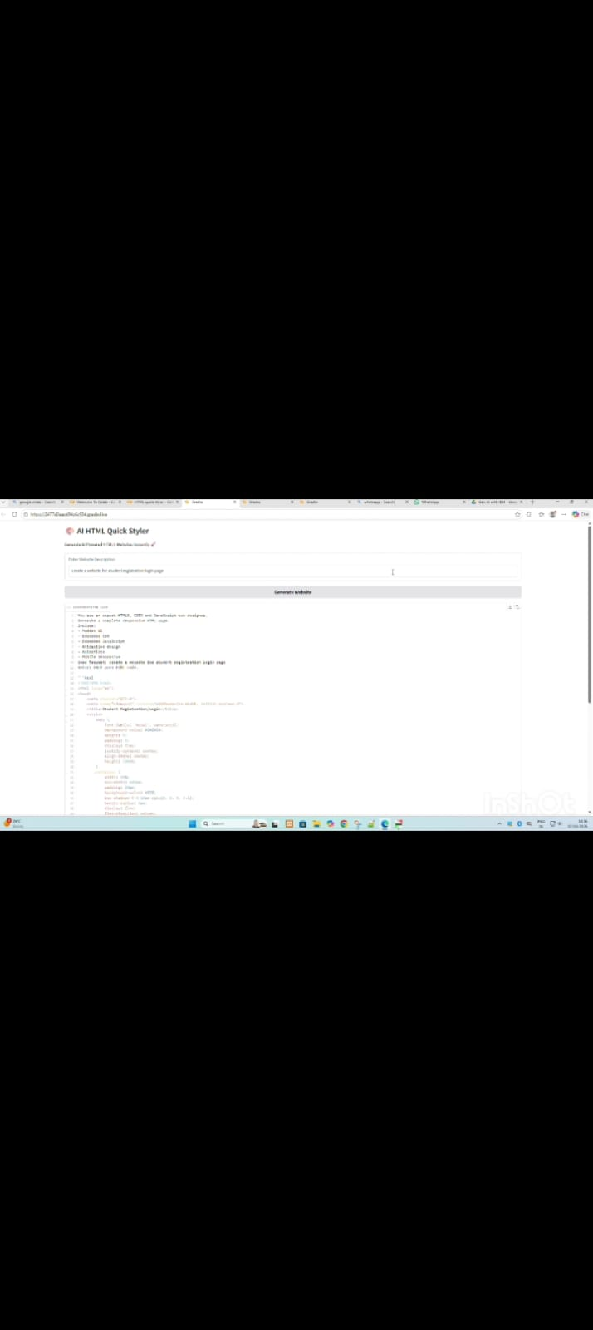
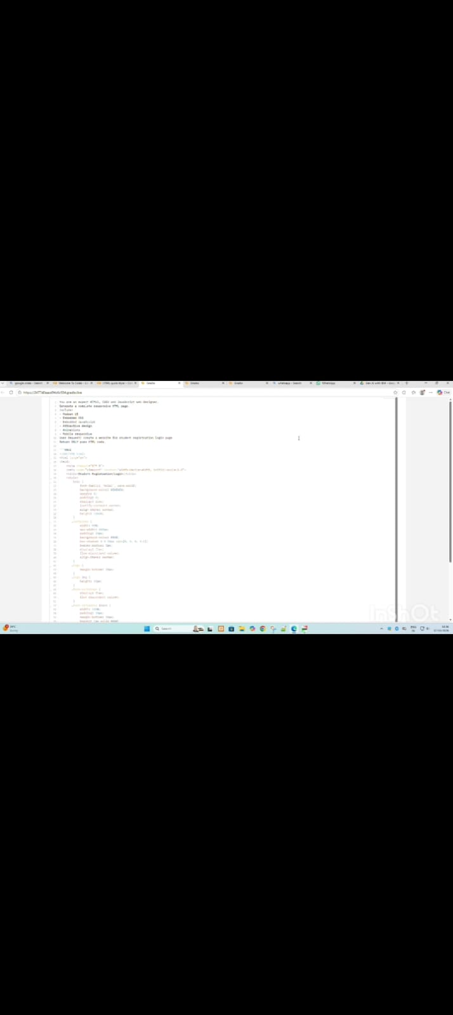
MILESTONE 1: Environment Setup &amp; Model Configuration
Establish Google Colab environment and configure Granite model
Activity 1.1: Install Dependencies &amp; Setup Environment
Create requirements.txt:
Code reference (hint: click on image and you can copy paste from Comment)
Activity 1.2: Configure IBM Granite Model
Access Hugging Face and load model:
Model: ibm-granite/granite-3.3-2b-instruct
Colab Notebook:
MILESTONE 2: Core Application Development
Activity 2.1: Color Palette Generator Implementation
Create ColorPaletteGenerator class with 8 predefined color schemes:
The ColorPaletteGenerator class provides cohesive color palettes for different design styles
including modern, vibrant, ocean, forest, sunset, luxury, creative, and minimal. Each palette
includes primary, secondary, accent, background, surface, text primary, text secondary, and
border colors optimized for dark theme interfaces.

Activity 2.2: HTML Page Builder Implementation
The HTMLPageBuilder class includes:
• Section extraction from user descriptions
• Keyword detection for hero, features, about, portfolio, testimonials, pricing, contact,
and footer sections
• SEO meta tags generation with Open Graph and Twitter Card support
• Individual section HTML generation with professional templates
Activity 2.3: CSS Generation Engine
The CSS generator creates comprehensive styling including:

• CSS variables for dynamic color management
• Gradient backgrounds and modern animations
• Responsive grid layouts with Flexbox and CSS Grid
• Smooth transitions and hover effects
• Mobile-first media queries for tablets and phones

• Sticky header with backdrop blur effect
• Card-based components with depth and shadows

MILESTONE 3: Gradio Interface Development
Activity 3.1: Main Interface with Multiple Tabs

MILESTONE 4: Deployment
Activity 4.1: Google Colab Deployment
Launch the application in Google Colab:
The application will be accessible via:
• Public URL: : https://87205c7f5a55c5adc8.gradio.live

MILESTONE 5: Testing &amp; Validation
Activity 5.1: Functional Testing
Test Case 1: Portfolio Website Generation
Input:
• Title: Modern Portfolio Website
• Description: Hero section with welcome message, features list with 3 items, about
section, portfolio gallery, testimonials, contact form, and footer
• Color Style: modern

Expected Output:


HTML Quick-Styler successfully delivers an intelligent web page generation assistant that
combines intuitive design templates with IBM Granite 3.3 2B Instruct model capabilities. By
leveraging Gradio&#39;s powerful interface framework and Google Colab&#39;s cloud infrastructure, the
system provides fast, professional, and customizable HTML/CSS generation accessible to
designers, developers, and non-technical users alike.

The platform demonstrates the viability of AI-assisted web development, making professional
page creation accessible while maintaining high design standards, responsive layouts, and
production-ready code quality. With eight distinct color palettes, intelligent section detection,
and comprehensive template options, HTML Quick-Styler empowers users to create beautiful
websites in minutes rather than hours.

Future enhancements could include custom color picker integration, JavaScript interactivity
generation, component library expansion, and integration with popular web frameworks. The
modular architecture allows for easy extension and customization to meet evolving user needs
and design trends.

